|  |  |
| --- | --- |
|  | Student Name __________________________________________    **Eastern Goldfields College**  Mathematics Essentials 2018  Application 31 |
|  | Time allowed: 60 minutes Total Marks: 40 marks (10%) |

**DAILY ENERGY INPUT**

**Calculating BMI**

The Body Mass Index (BMI) is used to measure a person’s relative size. It is defined by

Mass = kg Height = m

Where Mass is the persons **weight in kilograms** and Height is the person’s **height in metres**.

The diagram below indicates the weight range using a person’s BMI.

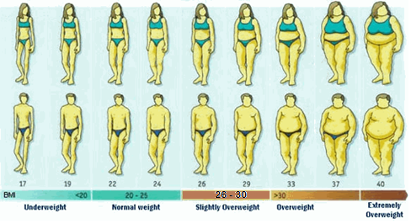  
1. Calculate the BMI for the following people, rounding to the nearest whole number. Show all your working.

(8 marks: 4, 4)

a. Adam is a 17 year old male, 178 cm, weighing 99 kg.

b. Alison is a 17 year old female, 172 cm tall, weighing 58 kg.

1. Using the diagram above, determine what weight range each of these people are in. (2 marks: 1, 1)  
   1. Adam’s weight range = __________________________
   2. Alison’s weight range = __________________________

**Calculating Calories**

A person’s energy input should match their energy output, unless they are trying to lose or gain weight. The energy potential of food and the energy expended, through exercise, by a person is measured in calories.

**Food Intake**

|  |  |  |
| --- | --- | --- |
|  | Age (years) | Maintain Weight (Approx. cal/day) |
| Male | 11 - 13 | 2200 |
| 14 - 18 | 2750 |
| Female | 11 – 13 | 2000 |
| 14 - 18 | 2100 |

To lose weight a person should reduce their calorie intake by 500 calories per day and to gain weight a person should increase their calorie intake by 500 calories per day.

1. In order to get into a healthy weight range, how many calories per day should each person have? (2 marks: 1, 1)
   1. Adam _________________________
   2. Alison _________________________
2. 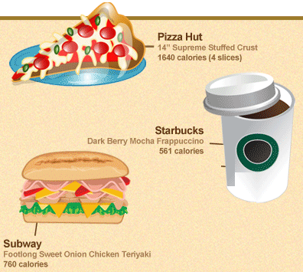Adam and Alison were given the following 2 options for the day. Calculate the number of calories for each option. (9 marks: 3, 3, 3)

OPTION 1

**Breakfast** - 1 Starbucks Dark Berry Mocha Frappuccino

**Lunch** – 1 Subway Footlong Chicken Teriyaki

**Dinner** – 2 slices of Supreme Pizza from Pizza Hut

a) What is the total number of calories for Option 1? Show working.

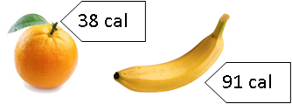**OPTION 2**

1 cup = 100 cal



1 cup = 130 cal

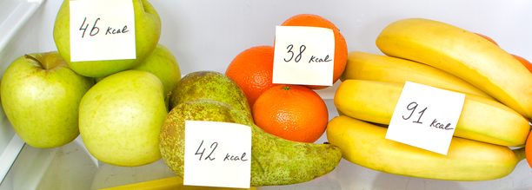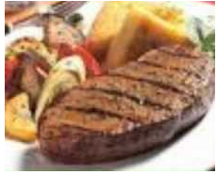

1 steak = 258 cal



50 g = 270 cal



1 plate = 230 cal



1 ice cream = 333 cal

Subway footlong Club   
640 calories

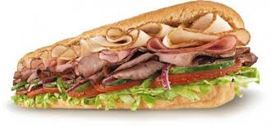

**Breakfast**  
 - 2 cups of Cheerios  
 - 1 ½ cups of Milk

**Morning Tea** - 50g Chips

**Lunch** – Subway footlong club sandwich

**Afternoon Tea** - 1 apple and 1 banana

**Dinner**  
 - 1 steak  
 - 1 plate of vegetables

**Dessert** – 1 ice cream

b) What is the total number of calories for Option 2? Show your working

c) Which would be the better option and give 2 reasons why?

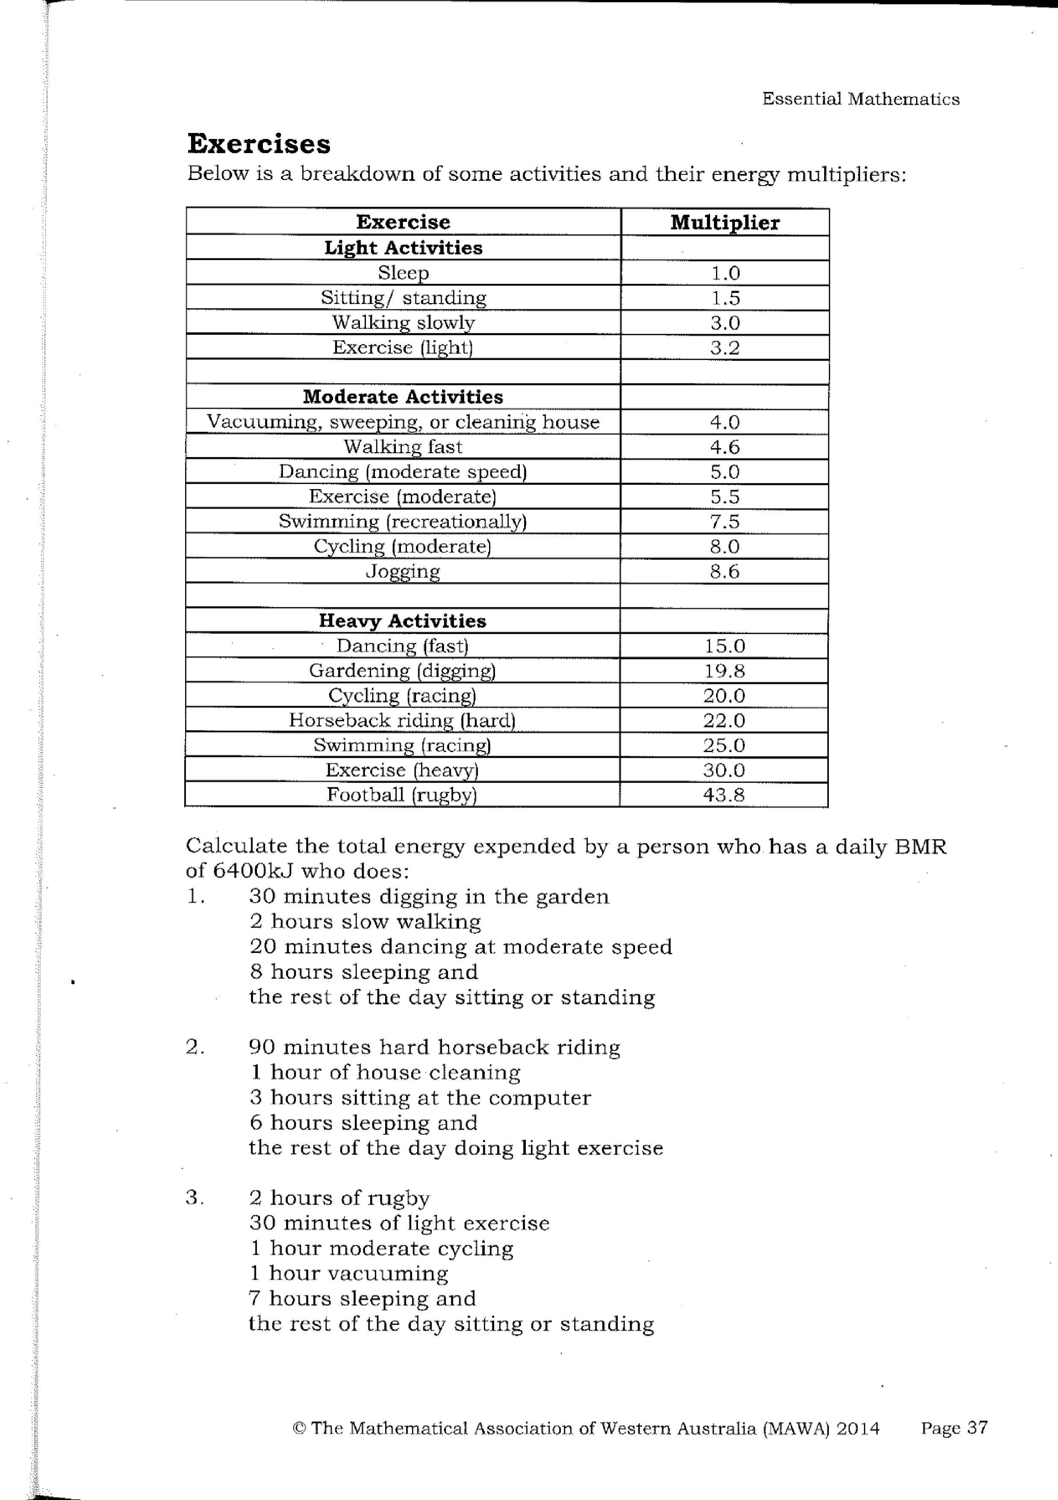**Exercise**

Eating too many calories can cause a person to put on weight and increase their BMI. However, you can reduce your daily calories through exercise. The table (right) is a breakdown of some activities and their energy multiplier.

To calculate the calories burnt through exercise is defined by

1. Calculate the number of calories burnt for each of the following exercises, rounding to 1 decimal place, where necessary. Show your working. (6 marks)

|  |  |  |  |
| --- | --- | --- | --- |
| **Exercise Activity** | **Duration** | **Multiplier** | **Calories Burnt / Exercise** |
| Vacuuming | ½ hour |  |  |
| Jogging | 20 min |  |  |
| Rugby Training | 1 hour |  |  |
| Walking Fast | ¾ hour |  |  |
| Bike ride – moderate pace | 1 hour |  |  |

1. Peter is a 17 year old male who is 1.76 m tall and weighs 102 kg. (13 marks: 2, 1, 2, 1, 2, 1, 3, 1)  
   1. Calculate Peter’s BMI, rounding to the nearest whole. Show your working.
   2. Peter wants to lose weight, what is Peter’s recommended food intake for a day?
   3. If Peter eats in one day, the same food as Option 2 (question 4), except he goes to Pizza Hut for dinner instead. So, instead of steak and vegetables, he eats 4 slices of Supreme pizza. Calculate Peter’s food intake for the day.
   4. What is the difference between what Peter has eaten to his recommended food intake for the day?
   5. On this day, Peter did a 40 minute jog in the morning and a 1 hour rugby training in the evening, how many calories did Peter burn through exercise for the day?
   6. Calculate Peter’s total energy input for the day.
   7. Peter’s goal is to lose weight, was this a successful day for Peter? Explain why/why not?
   8. What would happen to Peter if he continued with this outcome every day?